# ARUL JAYAM AGRI MACHINERY

# PROJECT WORK I REPORT

# Submitted by

# AMUDHAVAN M

# 22CSR014

# ANBARASAN T

# 22CSR017

# ARUNA A

# 22CSR021

***in partial fulfillment of the requirements***

***for the award of the degree***

***of***

# BACHELOR OF ENGINEERING

# IN

# COMPUTER SCIENCE AND ENGINEERING

**DEPARTMENT OF COMPUTER SCIENCE AND ENGINEERING**

# KONGU ENGINEERING COLLEGE

(**Autonomous)**

**PERUNDURAI ERODE – 638 060**

**MAY 2025**

**DEPARTMENT OF COMPUTER SCIENCE AND ENGINEERING**

**KONGU ENGINEERING COLLEGE**

**(Autonomous)**

**PERUNDURAI ERODE – 638 060**

**MAY 2025**

**BONAFIDE CERTIFICATE**

# This is to certify that the Project report entitled ARUL JAYAM AGRI MACHINERY is the bonafide record of the project work done by AMUDHAVAN M (Register No: 22CSR014), ANBARASAN T (Register No:22CSR017), ARUNA A (Register No: 22CSR021) in the partial fulfillment of the requirements for the award of the Degree of Bachelor of Engineering in Computer Science and Engineering of Anna University, Chennai during the year 2025- 2026.

## SUPERVISOR HEAD OF THE DEPARTMENT

**Date: (Signature with seal)**

Submitted for end semester viva voice examination held on __________________

**INTERNAL EXAMINER** **EXTERNAL EXAMINER**

**DEPARTMENT OF COMPUTER SCIENCE AND ENGINEERING KONGU ENGINEERING COLLEGE**

(**Autonomous**)

**PERUNDURAI ERODE – 638 060**

**MAY 2025**

**DECLARATION**

We affirm that the Project Report titled **ARUL JAYAM AGRI MACHINERY** being submitted in partial fulfillment of the requirements for the award of Bachelor of Engineering is the original work carried out by us. It has not formed the part of any other project report or dissertation on the basis of which a degree or award was conferred on an earlier occasion this or any other candidate.

Date: **AMUDHAVAN M**

**(22CSR014)**

**ANBARASAN T**

(**22CSR017)**

**ARUNA A**

**(22CSR021)**

I certify that the declaration made by the above candidate(s) is true to the best of my knowledge.

Date: Name and Signature of the Supervisor

**ABSTRACT**

**Arul Jayam Agri Machinery** is an agriculture-focused e-commerce platform developed to streamline the purchase and delivery of high-quality farming equipment and tools. Catering to the needs of farmers and agricultural businesses, the platform offers a user-friendly interface for browsing a wide range of machinery, including tractors, tillers, harvesters, and spare parts. With a focus on reliability and convenience, users can easily explore products, compare specifications, and place secure orders from their location, ensuring timely support for modern farming needs.

The application features a **user-friendly interface** powered by a **React frontend** and an **Express JS backend**, with seamless payment gateway integrationto enable secure online transactions. An **admin module** is incorporated to manage product listings, inventory, and customer orders efficiently. The platform also supports **order tracking** and delivers real- time updates to both users and administrators.

Designed with a focus on responsiveness and performance, the site uses **Tailwind CSS** for modern styling and **React Router** for smooth navigation. This project offers a scalable solution for small businesses looking to expand their reach during festive seasons, enhancing the shopping experience and operational efficiency through digital transformation.

**ACKNOWLEDGEMENT**

We express our sincere thanks and gratitude to **Thiru. A. K. ILANGO B.Com., M.B.A., LLB.,** our beloved Correspondent, and all other philanthropic trust members of Kongu Vellalar Institute of Technology Trust who have always encouraged us in academic and cocurricular activities.

We are extremely thankful with no words of a formal nature to the dynamic Principal **Dr. V. BALUSAMY, M.Tech., Ph.D.,** for providing the necessary facilities to complete our work.

We would like to express our sincere gratitude to our respected Head of the Department **Dr. S. MALLIGA, M.E., Ph.D.,** for providing the necessary facilities.

We extend our thanks to **Ms. R. S. SHUDAPREYAA, M.Tech.,** Assistant Professor, Computer Science and Engineering, Project Coordinator, for her encouragement and valuable advice that made us carry out the project work successfully.

We extend our gratitude to Supervisor **Dr. S. MALLIGA, M.E., Ph.D.,** Professor of Computer Science and Engineering, for her valuable ideas and suggestions, which have been very helpful in the project. We are grateful to all the faculty members of the Computer Science and Engineering Department for their support.

# TABLE OF CONTENTS

|  |  |  |
| --- | --- | --- |
| **CHAPTER No.** | **TITLE** | **PAGE No.** |
|  | **ABSTRACT** | **iv** |
|  | **LIST OF FIGURES** | **viii** |
| **1.** | **INTRODUCTION** | 1 |
|  | 1.1 EXISTING SYSTEM | 1 |
|  | 1.2 SYSTEM STUDY | 2 |
|  | 1.3 OBJECTIVE | 3 |
|  | 1.4 SCOPE | 3 |
| **2.** | **GENERAL DESCRIPTION** | **5** |
|  | 2.1 PROJECT PERSPECTIVE | 5 |
|  | 2.2 USER CHARACTERISTICS | 5 |
|  | 2.3 DESIGN AND IMPLEMENTATION CONSTRAINTS | 6 |
| **3.** | **REQUIREMENTS** | **8** |
|  | 3.1 FUNCTIONAL REQUIREMENTS | 8 |
|  | 3.2 NON-FUNCTIONAL REQIREMENTS | 10 |
|  | 3.3 USER INTERFACES | 10 |
| **4.** | **DETAILED DESIGN** | **13** |
|  | 4.1 ARCHITECTURAL DESIGN | 13 |
|  | 4.1.1 MODULE CHARACTERISTICS | 13 |
|  | 4.1.1.1 USER MODULE | 13 |
|  | 4.1.1.2 ADMIN MODULE | 14 |

|  |  |  |
| --- | --- | --- |
|  | 4.1.1.3 FLOW CHART | 14 |
|  | 4.1.1.4 USE CASE DIAGRAM | 15 |
|  | 4.1.1.5 SEQUENCE DIAGRAM | 17 |
|  | 4.2 INTERFACE DESIGN | 18 |
|  | 4.3 DATABASE DESIGN | 18 |
|  | 4.4 OUTPUT DESIGN | 18 |
| **5.** | **TESTING** | 19 |
|  | * 1. 5.1 UNIT TESTING | 19 |
|  | 5.2 REGRESSION TESTING | 19 |
|  | 5.3 VALIDATION TESTING | 19 |
|  | 5.4 VERIFICATION TESTING | 20 |
|  | 5.5 INTEGRATION TESTING | 20 |
| **6.** | **CONCLUSION AND FUTURE SCOPE** | 21 |
|  | APPENDIX 1 | 23 |
|  | APPENDIX 2 | 27 |
|  | REFERENCES | 31 |

## LIST OF FIGURES

|  |  |  |
| --- | --- | --- |
| **FIGURE NO.** | **TITLE** | **PAGE NO.** |
| 3.1  3.2  3.3  4.1  4.2  4.3 | HOME PAGE  PRODUCTS PAGE  CART PAGE  FLOW CHART  USE CASE DIAGRAM    SEQUENCE DIAGRAM | 11  11  12  15  16  17 |

**CHAPTER 1**

**INTRODUCTION**

In today’s digital era, e-commerce platforms are vital in delivering products efficiently to customers across regions. Arul Jayam Agri Machinery is a MERN stack-based web application developed to support farmers and agri-based businesses by offering easy access to agricultural tools and machinery. The platform enables real-time browsing of products, detailed specifications, and comparison features. It ensures secure online ordering and smooth inventory and order management. Designed for rural and semi-urban users, it bridges the gap between modern technology and traditional farming needs.

The Arul Jayam Agri Machinery platform empowers admins with a centralized dashboard to efficiently oversee all operations. Real-time inventory tracking helps prevent stockouts and ensures timely restocking of machinery and parts. Advanced analytics provide insights into sales trends, customer behavior, and order history. Integration with SMS and email notifications keeps both admins and customers informed. Role-based access control ensures data privacy and operational security. Built with modern web technologies, the platform supports multi-device accessibility for seamless user experience anywhere, anytime.

* 1. **EXISTING SYSTEM**

The traditional retail approach lacks real-time updates on stock and delivery status, causing delays and inefficiencies. Farmers face challenges in comparing product features, prices, and availability across different vendors. Limited working hours and long travel distances to physical stores further hinder timely procurement. Without a centralized system, customer records and order histories are poorly maintained or completely missing. After-sales service and support are often informal, inconsistent, and difficult to access. Overall, the absence of a streamlined, tech-enabled solution creates barriers to efficient and informed agricultural machinery purchases.

Unlike generic e-commerce platforms, Arul Jayam Agri Machinery is purpose-built to serve the unique needs of the agricultural sector. It offers detailed equipment specifications, warranty tracking, and localized product recommendations based on crop cycles and regional demand. The platform is optimized to handle seasonal traffic spikes, ensuring consistent performance during peak farming periods. Features like demo booking, spare parts availability, and maintenance scheduling enhance customer satisfaction. Admins benefit from a unified dashboard for inventory management, order tracking, and actionable sales insights. This tailored approach ensures a reliable, efficient, and farmer-centric digital commerce experience.

* 1. **SYSTEM STUDY**

**1.2.1 Understanding the Project Requirements**

The Arul Jayam Agri Machinery system ensures ease of use with its responsive design, accessible across mobile, tablet, and desktop devices. Farmers can explore detailed product listings, compare options, and make informed purchases with confidence. Real-time order tracking keeps users updated from purchase to delivery. The secure payment gateway protects transactions and builds trust among rural customers. For admins, the intuitive dashboard streamlines operations and provides insights into sales, customer behavior, and inventory status. Overall, the platform bridges the digital gap in agricultural commerce with a reliable, user-friendly experience.

**1.2.2 Analysing User Experience**

The Arul Jayam Agri Machinery platform is designed with a farmer-first approach, ensuring that every interaction is simple and intuitive. A streamlined interface allows customers to quickly search for machinery, view detailed specifications, and compare products with ease. The shopping experience is enhanced by a secure checkout process and real-time order tracking. For administrators, the backend offers efficient tools to update inventory, adjust pricing, and manage incoming orders swiftly. This digital solution significantly reduces the time and effort involved in traditional purchases. It enhances transparency, improves access to quality machinery, and supports informed buying decisions.

**1.2.3 Identifying User Needs**

The target users of the Arul Jayam Agri Machinery system include:

* **Farmers** – Individuals seeking easy access to agricultural tools and machinery with reliable delivery options.
* **Agri-Business Owners** – Users requiring bulk orders and quick access to product details and specifications.
* **Admin Users** – Managers responsible for maintaining product listings, updating inventory, handling orders, and monitoring customer data.

Key user needs include clear product listings, equipment specifications, secure payments, order tracking, and seasonal discounts or service offers.

**1.2.4 Developing Use Cases**

* **Customer Use Case**: A customer logs in, browses products, adds to the cart, pays securely, and receives order confirmation with tracking..
* **Admin Use Case**: An admin logs in, adds products, checks orders, updates stock, and generates sales reports.
* **Returning Customer Use Case**: A returning customer logs in, views past orders, and reorders with updated payment and product details.

**1.3 OBJECTIVE**

The core goal of the Arul Jayam Agri Machinery project is to digitize and simplify the agricultural machinery buying process through a robust MERN stack-based web application. By enabling real-time browsing and secure online purchases, the platform addresses the limitations of traditional retail systems, especially for farmers in remote areas. It is designed to handle high user traffic during peak seasons while maintaining smooth performance. The integrated admin module empowers business owners to manage inventory, orders, and customer data efficiently. With secure payment gateways and responsive design, the platform ensures convenience, trust, and accessibility. Ultimately, it enhances operational efficiency and delivers a seamless experience for both farmers and administrators.

* 1. **SCOPE**

This project involves the development of a specialized e-commerce platform for purchasing agricultural machinery online. It includes:

* A customer interface for browsing, ordering, and paying for machinery.
* An admin panel for managing products, inventory, and orders.
* Integration of secure payment gateways for online transactions.
* Mobile-friendly and responsive design for easy access across devices.
* Seasonal offers and product visibility enhancements to handle demand.
* Order history, tracking, and confirmation system for customer convenience.

Arul Jayam Agri Machinery is built with scalability and future enhancements in mind, ensuring long-term value and adaptability. Planned upgrades include integration with delivery partner APIs for real-time shipping updates and automated logistics management. Advanced sales analytics will provide deeper insights into customer behavior, demand trends, and business performance. Push notifications will enhance user engagement by alerting customers about order status, offers, and new arrivals. The system is engineered to maintain high performance during peak usage periods. Robust data security measures and strict privacy protocols safeguard customer information, fostering trust and reliability across the platform.

## CHAPTER 2

## GENERAL DESCRIPTION

**2.1 PROJECT PERSPECTIVE**

Arul Jayam Agri Machinery leverages the growing shift towards digital commerce to meet the evolving needs of the farming community. By enabling online purchases, it reduces dependency on time-consuming and often distant physical store visits. The platform offers a seamless shopping experience with secure payment gateways and real-time order tracking, ensuring transparency and trust. Its intuitive interface is designed for ease of use, even for users with limited digital literacy. Accessibility is further improved through mobile responsiveness, allowing farmers to shop anytime, anywhere. Overall, the system brings convenience, efficiency, and modernity to agricultural machinery procurement.

Arul Jayam Agri Machinery is a MERN-stack platform (MongoDB, Express.js, React.js, Node.js) that lets farmers and agri-businesses browse detailed machinery listings, place orders, and pay securely online. A mobile-responsive interface, real-time order tracking, and integrated payment gateways create a seamless, trustworthy shopping experience for users in both urban and rural areas—even during seasonal traffic spikes.

Behind the scenes, an intuitive admin module streamlines product uploads, inventory control, pricing updates, order processing, and delivery tracking. Built for scalability, the system maintains high performance during campaign surges, and its architecture supports future upgrades such as delivery-partner API hookups, advanced sales analytics, and push notifications—ensuring the platform grows with evolving agricultural-commerce needs.

**2.2 USER CHARACTERISTICS**

For the Arul Jayam Agri Machinery platform, understanding the characteristics of both end-users and admin users is crucial to delivering an effective system.

Customers (Users)

* Primarily farmers and agri-business owners looking to purchase machinery or tools for their farming need.
* Expect a simple, responsive interface to easily browse, search, and filter products.
* Require secure, fast checkout options with integrated payment gateways (e.g., Razorpay, PayPal, Stripe) for seamless transactions.

Administrators (Admins)

* Responsible for maintaining the platform, managing product listings, processing orders, and handling customer queries.
* Admins need access to dashboard analytics, inventory management, and product visibility control to ensure smooth operations and timely updates.
* Admins need tools to manage seasonal price updates, set delivery timelines, and securely log payment transactions.

**2.3 DESIGN AND IMPLEMENTATION CONSTRAINTS**

**2.3.1 Time**

Time is a critical factor for the success of the Arul Jayam Agri Machinery platform, as the project must be completed within a specific timeframe to ensure it is operational before key agricultural seasons. Delays in development, testing, or deployment could disrupt the platform's launch, leading to missed opportunities during peak sales periods. This could negatively affect business operations, as farmers and agri-businesses rely on the platform for timely purchases of machinery and equipment. Therefore, strict adherence to deadlines is essential for maximizing market effectiveness and ensuring the platform’s success in meeting the needs of the farming community during high-demand seasons.

**2.3.2 Budget Limitations**

As a seasonal product-based platform, Arul Jayam Agri Machinery may encounter budget constraints that could limit the ability to invest in premium hosting services, advanced analytics tools, or third-party libraries. To ensure the platform is functional within these limitations, the focus will be on prioritizing essential features such as product management, secure payment processing, and real-time order tracking. While optional enhancements and advanced functionalities like detailed analytics or additional integrations may be considered in future phases, the initial launch will concentrate on delivering a reliable and user-friendly experience. By streamlining the scope, the project can ensure cost-effectiveness while still addressing the core needs of users and administrators.

**2.3.3 Security**

Security is a critical aspect of the Arul Jayam Agri Machinery platform, given the integration of online payments and the management of sensitive customer data. To ensure the highest level of protection, the platform will employ secure authentication methods like JWT (JSON Web Tokens) for safe session management, along with bcrypt for securely hashing passwords. All data communication between the client and server will be encrypted using HTTPS, ensuring that sensitive information is protected from interception. Additionally, the platform will use advanced encryption techniques for storing user data, ensuring that personal and payment details remain safe at all times. Compliance with global data protection regulations, such as GDPR, will be strictly adhered to, ensuring transparency in data handling and safeguarding user privacy. This comprehensive approach will help build trust with users and ensure legal and regulatory compliance.

**2.3.4 Scalability**

During peak agricultural seasons, the Arul Jayam Agri Machinery platform must be able to handle significant increases in user traffic and order volumes. To ensure the system remains responsive and reliable, its architecture must be scalable. Implementing load balancing will distribute traffic across multiple servers, preventing any single server from being overwhelmed. Additionally, using database indexing and optimizing queries will reduce response times and improve data retrieval efficiency, ensuring smooth operation even with large volumes of orders and customer interactions. These strategies will help maintain high system performance, delivering a seamless and uninterrupted user experience during peak periods, ensuring that the platform remains available and efficient when it's needed the most.

## CHAPTER 3

## REQUIREMENTS

**3.1 FUNCTIONAL REQUIREMENTS**

**3.1.1 User Authentication**

The Arul Jayam Agri Machinery platform will implement secure authentication for both customers and admins, allowing them to register, log in, and log out safely. User credentials will be protected using bcrypt for password hashing, and session management will be handled via JWT to ensure secure, session-based access. Role-based access control (RBAC) will restrict access, ensuring that customers can only view their specific features like the cart and order tracking, while admins have exclusive access to the admin dashboard for managing inventory, orders, and analytics. This approach ensures secure access while maintaining the integrity of both user and admin functionalities.

**3.1.2 Product Browsing and Search**

The Arul Jayam Agri Machinery platform will allow users to browse agricultural machinery organized into categories such as tractors, plows, and other farming equipment. Users can easily search for specific products using a search bar and apply filters like price range, brand, and seasonal discounts to narrow down their options. This feature will enable a personalized and efficient shopping experience, helping users quickly find the machinery that best meets their needs. Additionally, the intuitive categorization and filtering options will enhance product discovery and improve overall user satisfaction.

**3.1.3 Cart Management**

The Arul Jayam Agri Machinery platform will allow users to add machinery to their cart, update quantities, and remove items with ease. The cart will persist across sessions, ensuring that users' selections remain intact even if they log out or close the browser. This persistent cart functionality will improve the user experience by allowing customers to continue shopping seamlessly without losing their selections. Users will also have the option to review and adjust the contents of their cart before proceeding to checkout, providing flexibility and convenience throughout the shopping process.

**3.1.4 Secure Checkout and Payment Integration**

The Arul Jayam Agri Machinery platform will offer a secure and streamlined checkout process, where users can enter their shipping details and proceed to payment via integrated gateways like Razorpay or Stripe. The checkout flow will ensure that sensitive information, such as payment and shipping details, is handled securely. After completing the purchase, users will receive an order confirmation with tracking details, allowing them to monitor the status of their order in real-time. This secure and transparent process will enhance user trust and provide a smooth, efficient shopping experience from start to finish.

**3.1.5 Admin Product and Inventory Management**

Admins should be able to:

* Add, edit, or delete product listings.
* Update stock quantities and pricing.
* Mark products as featured or season-specific for better visibility and promotion.
* View low-stock alerts.

**3.1.6 Order Management**

The Arul Jayam Agri Machinery platform will enable admins to view, process, and update the status of customer orders, including statuses such as "pending," "shipped," or "delivered." This functionality allows admins to efficiently manage orders and keep customers informed about their order's progress. Customers will also be able to view their order history and track the status of their current orders through their user dashboard, providing them with real-time updates on the delivery process. This ensures transparency, improves customer satisfaction, and streamlines order management for admins.

**3.1.7 Offers and Seasonal Campaigns**

The Arul Jayam Agri Machinery platform will allow admins to add seasonal offers or discount codes that users can apply during checkout. This feature will enable admins to create targeted promotions and discounts, especially during peak agricultural periods, to encourage purchases and boost sales. By offering special deals on specific machinery or tools, admins can effectively promote particular products, increase customer engagement, and support marketing efforts. Users will have the opportunity to apply these discount codes during checkout, enhancing the overall shopping experience and providing added value.

**3.2 NON-FUNCTIONAL REQUIREMENTS**

**3.2.1 Performance**

* The website should maintain fast response times for both customer and admin actions.
* Payment processing, cart updates, and order placement should occur with minimal latency.
* Images and product data should be optimized for quick loading.

**3.2.2 Usability**

* The UI should be responsive and easy to navigate across devices (desktop and mobile).
* Clear CTAs (Call to Action), clean layouts, and intuitive menus should guide users smoothly through browsing and checkout.
* The admin panel should provide easy access to key features like product updates and order overviews.

**3.2.3 Reliability**

* All critical user flows (login, checkout, order update) must include proper validation and error handling.
* The system should gracefully handle unexpected scenarios, such as failed payments or unavailable products.

**3.2.4 Availability**

* The platform should be available 24/7, especially during high-demand seasons.
* Scheduled maintenance should be communicated in advance.
* Regular backups and recovery strategies should be implemented to prevent data loss.

## 3.3 USER INTERFACES

## HOME PAGE

Figure 3.1shows the Home page of Arul Jayam Agri Machinery with a clean and responsive layout, featuring a navigation bar that includes Home, Cart, Orders, and Login links. A high-resolution banner highlights “Harvesting Equipment” with a call-to-action “Learn More” button, enhancing user engagement and guiding customers toward exploring machinery products.

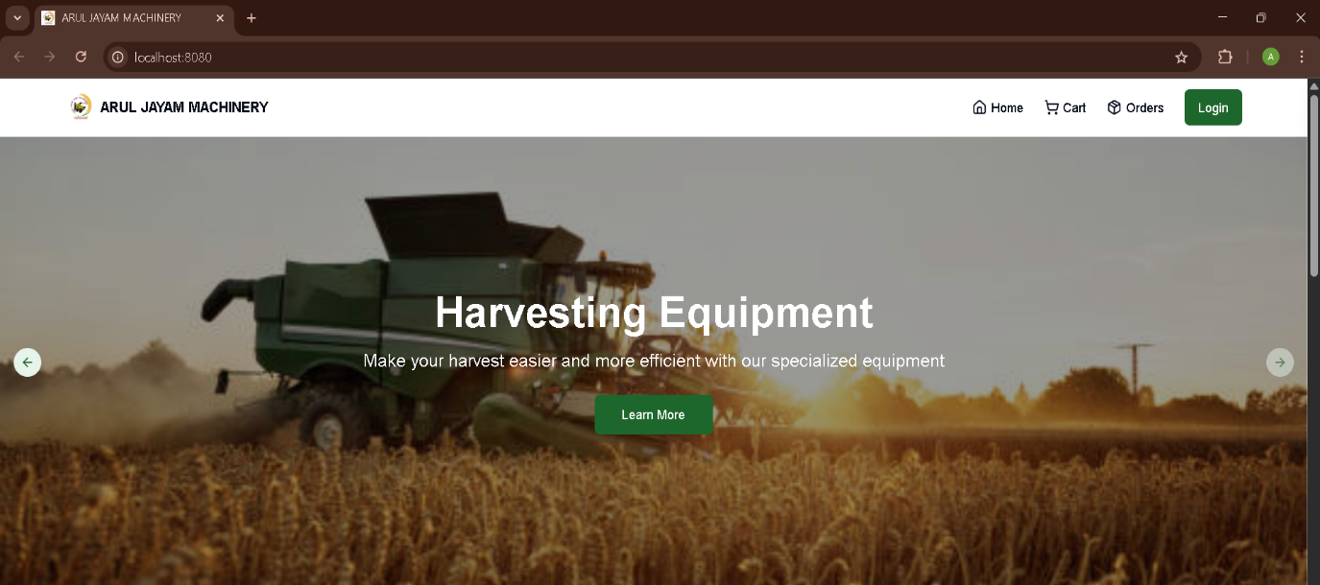

**FIGURE 3.1 Home Page**

**PRODUCTS PAGE**

Figure 3.2shows the Products page of Arul Jayam Agri Machinery, featuring a categorized list of agricultural equipment with product images, names, brief descriptions, and prices. Users can filter products by price range, category, color, and specifications. Each item includes a "View Product" button, enhancing the browsing and selection experience for customers.

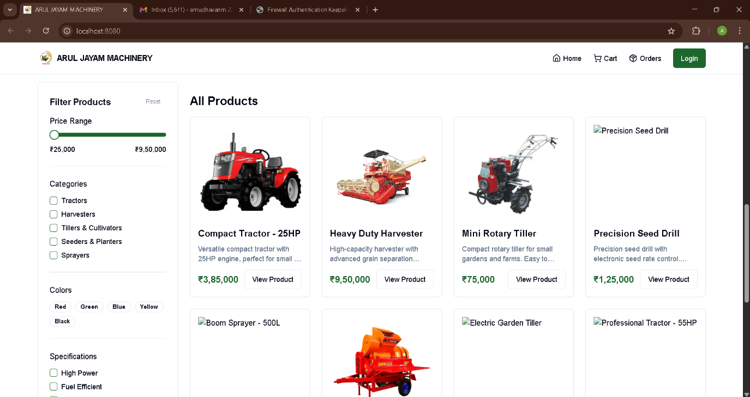

**FIGURE 3.2 Products Page**

## CART PAGE

Figure 3.3shows the Shopping Cart page of Arul Jayam Agri Machinery, listing selected agricultural equipment with details such as product name, color, quantity, and individual price. An Order Summary panel on the right displays the subtotal, shipping information, and total cost. A clearly visible "Proceed to Checkout" button enables users to move forward with the purchase.

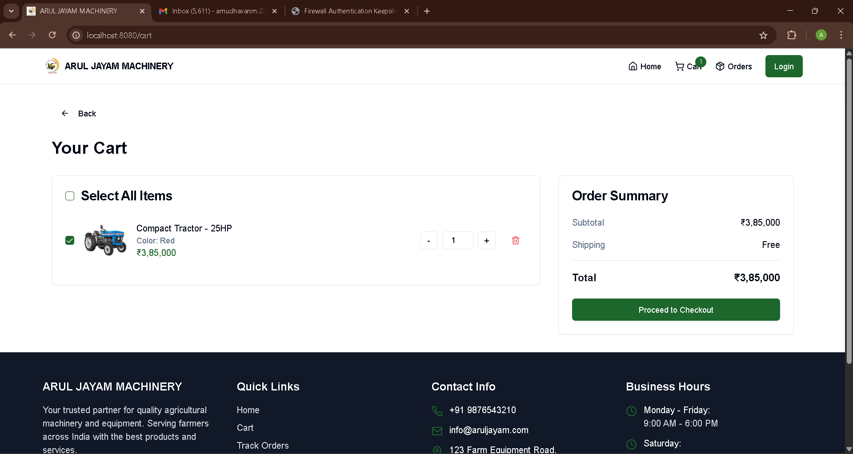

**FIGURE 3.3 Cart Page**

**CHAPTER 4**

## DETAILED DESIGN

* 1. **ARCHITECTURAL DESIGN**

The architectural design of the Arul Jayam Agri Machinery platform follows a modular approach, ensuring scalability and maintainability. It incorporates various diagrams, including use case diagrams to represent the primary interactions between customers, admins, and the system, highlighting key functionalities like browsing, purchasing, and order management. Sequence diagrams detail the step-by-step flow of actions within the system, such as the process of adding items to the cart, completing a purchase, and updating order statuses. Activity diagrams illustrate the flow of tasks, such as admin order processing and customer checkout, providing a clear understanding of how users and administrators interact with the platform at each stage. These visual representations ensure a comprehensive and organized understanding of the platform’s architecture and functionality.

**4.1.1 MODULE CHARACTERISTICS**

This project consists of two core modules:

* User Module
* Admin Module

**4.1.1.1 User Module:**

The **User Module** allows customers to interact with the platform in the following ways:

* **Home Page and Product Catalogue:** Displays a wide range of agricultural machinery categorized by type (e.g., tractors, plows, harvesters). Customers can browse, search, and view detailed product descriptions, images, prices, specifications, and availability.
* **Cart and Checkout:** Users can add products to their cart, modify quantities, and proceed to checkout. Secure payment integration allows them to place orders with confirmation.
* **Order History and Tracking:** Once orders are placed, users can view past orders and track current ones based on their status (pending, shipped, delivered).
* **Offers and Announcements:** Users can view season-based promotions, bundle deals, and location-specific delivery information.
* **Shipping and Payment**: Users can enter their shipping details and choose from secure payment options (e.g., UPI, net banking, credit/debit card) to complete their purchase.
* **Login/Register**: Allows users to create a new account or log in to an existing one using secure authentication methods.
* **Order Confirmation**: After successful payment, users receive an order confirmation with order ID and estimated delivery date.

**4.1.1.2 Admin Module**

Admins manage product listings, inventory, and customer orders. Key features include:

* **Product Management**: Add, update, or remove items, edit stock levels, and apply discounts.
* **Inventory Management**: Admins can monitor stock levels, update quantities, and receive low-stock alerts to ensure timely restocking.
* **Order Management**: View incoming orders, update status (processed, shipped, delivered), and access customer details.
* **Reports**: View analytics on sales trends, top-selling products, and customer activity.
* **Security Controls**: Manage roles, access levels, and ensure system integrity.

**4.1.1.3 FLOW CHART**

A flowchart is a visual tool that maps out the sequence of steps, decisions, and actions within a system or process. It typically uses standardized symbols like ovals for the start and end points, rectangles for processes or tasks, diamonds for decision points, and arrows to show the flow of control. Flowcharts help to break down complex workflows into understandable segments, making them an essential tool for both planning and communication. In the context of the Arul Jayam Agri Machinery platform, a flowchart could be used to depict the entire user journey, from browsing products to completing a purchase, and also to illustrate admin processes like order management and status updates. This makes it easier to identify potential inefficiencies, ensure smooth system operation, and align the development process with user needs.

## 

## FIGURE 4.1 FLOW CHART

Figure 4.1 shows the flow starting with user authentication. Customers browse products, add items to their cart, proceed to check out, and place orders. Admins manage the backend: products, stock, and orders. Payment confirmation updates order statuses.

## 4.1.1.4 USE CASE DIAGRAM

## A Use Case Diagram is one of the primary UML (Unified Modeling Language) diagrams used to capture the functional requirements of a system by modeling the interactions between users (actors) and the system. It provides a high-level view of the system’s functionality and how different user types (e.g., customers and administrators) interact with it. In a Use Case Diagram, actors represent the users or external systems, and use cases represent the functionalities or processes the system offers to the actors.

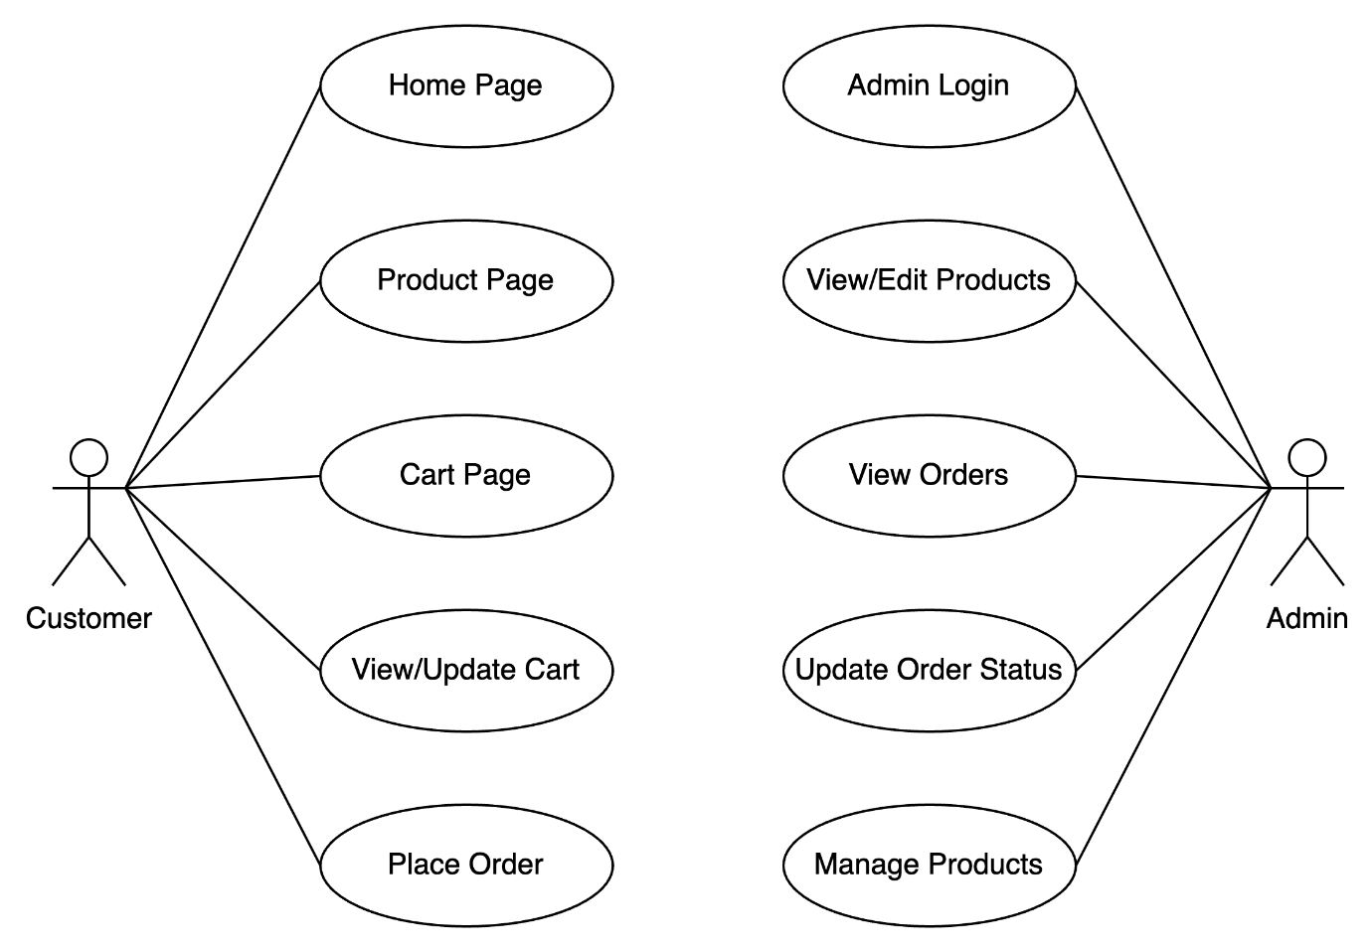

**FIGURE 4.2 USE CASE DIAGRAM**

Figure 4.2 shows the Use Case Diagram for the Arul Jayam Agri Machinery platform clearly illustrates the primary interactions between customers and administrators. Customers can perform tasks such as browsing agricultural machinery, adding products to their cart, and placing secure orders for checkout. On the other hand, Administrators have access to the admin panel where they can log in, manage product listings, process customer orders, and update order statuses. This well-defined structure ensures that both front-end and back-end operations function seamlessly, providing an efficient and streamlined user experience. By separating the functionalities of customers and administrators, the platform ensures smooth and effective interactions for both retail-facing activities and backend management.

**4.1.1.5 SEQUENCE DIAGRAM**

A Sequence Diagram is a dynamic UML diagram that models the interactions between objects in a system over time. In the Arul Jayam Agri Machinery platform, it illustrates the sequence of actions, such as when a customer places an order or an admin updates a product listing. For instance, when a customer orders a product, the customer interacts with the cart system, proceeds to checkout, enters payment details, and receives order confirmation, while the payment gateway processes the transaction. Similarly, for admins, the sequence includes logging into the admin panel, updating product information, and reflecting those changes in the system. This diagram helps visualize the step-by-step flow of interactions, ensuring smooth functionality and dynamic system behavior.

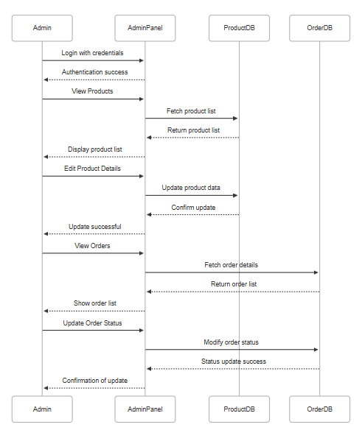

## FIGURE 4.3 SEQUENCE DIAGRAM

**Figure 4.3** illustrates the structured flow of interactions in the Arul Jayam Agri Machinery system. Customers browse machinery listings, add items to their cart, and place orders, which triggers the storage of order and user data. Admins securely log into the backend, retrieve order details, manage inventory, and update order statuses. This synchronized flow ensures real-time coordination between the frontend and backend, enabling efficient inventory control and order fulfillment.

## 4.2 INTERFACE DESIGN

The interface is built with **ReactJS and Tailwind CSS**, offering a modern and responsive experience. Key interfaces include:

* **Home Page**: Displaying details of the shop
* **Product Details Page**: Full item information with an add-to-cart option
* **Admin Dashboard**: Navigation to manage orders, products, and reports
* **Mobile Responsiveness**: Ensures usability across devices

**4.3 DATABASE DESIGN**

The database is built using **MongoDB**, supporting collections like:

* **Users**: Stores customer and admin credentials and profiles.
* **Products**: Stores cracker details like name, category, stock, price, and image.
* **Orders**: Tracks each order with user ID, product list, total amount, payment status, and timestamps.
* **Offers**: Stores season-specific deals and their expiry dates for promotional use.

Data integrity and indexing ensure fast and secure access.

**4.4 OUTPUT DESIGN**

Output is focused on user experience and clarity. Key outputs include:

* **Order Confirmation**: Displays product summary, price, and delivery estimate.
* **Admin Reports**: Tabular views and charts for sales statistics, order statuses, and inventory levels.

**Notifications**: Real-time alerts for order updates, offer announcements, and admin actions.

Outputs are presented using visually engaging charts, tables, and dashboards.

**CHAPTER 5**

**TESTING**

**5.1 UNIT TESTING**

Unit testing is an essential process for ensuring the reliability of the Arul Jayam Agri Machinery platform's components. Key modules such as machinery listings, user authentication, cart management, and order placement were tested individually to confirm they operate as expected. The tests covered typical scenarios as well as edge cases to verify robustness. The user authentication module was tested to ensure secure login and session management. Cart management functionality was validated to handle adding, updating, and removing items correctly. The order placement process was tested to ensure accurate processing, including payment integration and order status updates. Manual test cases were used for specific scenarios that require human judgment, while automation tools streamlined the testing of repeated tasks. These tests were conducted in isolation to ensure each component functions independently before integration. The testing process helped identify any issues early and provided a stable foundation for the platform. Ultimately, unit testing ensured that the platform’s features are reliable and ready for integration with other system components.

**5.2 REGRESSION TESTING**

Regression testing was performed after each update or feature enhancement on the Arul Jayam Agri Machinery platform to ensure that no previously functional components were disrupted. For example, after integrating updates to the machinery listings, payment gateway, or cart functionality, modules such as cart management and order processing were re-tested to verify that the changes did not affect existing features. This approach helps maintain the reliability of the system after each release, ensuring that updates or new features do not unintentionally break or degrade existing functionality. By conducting regression testing regularly, the platform delivers a consistent and smooth experience for both customers and administrators, minimizing the risk of errors in production.

**5.3 VALIDATION TESTING**

Validation testing was conducted to ensure that the Arul Jayam Agri Machinery platform met both business requirements and user expectations. It confirmed that customers could register, browse machinery listings, add items to their cart, complete secure checkouts, and receive order confirmations without issues. For admins, validation testing ensured that they could successfully update product listings, manage orders, and control inventory. This phase of testing was crucial in verifying that the system performed as intended in the production environment, ensuring that all features functioned correctly and met the platform's goals. By validating the platform’s functionality across different user roles, this testing phase helped confirm the system's accuracy, reliability, and readiness for deployment.

**5.4 VERIFICATION TESTING**

Verification testing was carried out throughout the development of the Arul Jayam Agri Machinery platform to ensure that each component adhered to the specified design and requirements. Modules such as user authentication, machinery updates, and order processing were verified individually before being integrated into the full system. This approach helped ensure that each module functioned as intended and met the design specifications. Verification testing also played a key role in identifying discrepancies early in the development process, allowing for timely adjustments. By confirming that each module aligned with the intended design and functionality, this phase helped ensure the platform's overall integrity and readiness for subsequent testing phases.

**5.5 INTEGRATION TESTING**

Integration testing was focused on evaluating the interaction between interconnected modules in the Arul Jayam Agri Machinery platform. Key areas tested included linking the customer checkout process with the payment gateway, ensuring seamless order placements, and synchronizing order management with inventory updates. Additionally, the interaction between customer and admin modules, such as order tracking and notifications, was thoroughly tested to confirm smooth data flow and communication across the system. This phase ensured that all components worked together as a cohesive system, providing a seamless and efficient experience for both customers and administrators. By testing the integration of these critical modules, any potential issues were identified and resolved, ensuring the platform’s smooth operation post-launch.

**CHAPTER 6**

**CONCLUSION AND FUTURE WORK**

The development of the Arul Jayam Agri Machinery platform has resulted in a robust, seasonal e-commerce solution tailored for farmers and agri-businesses, allowing them to easily purchase machinery during peak agricultural seasons. Built using the MERN stack (MongoDB, Express.js, ReactJS, Node.js), the platform delivers an efficient experience for both customers and administrators. Customers can easily register, browse a wide range of machinery listings, add products to their cart, and complete secure transactions with confidence. On the other hand, admins have the capability to manage product listings, track customer orders, update inventory levels, and monitor sales analytics. This dual functionality ensures the platform supports both user-facing and backend operations seamlessly, providing a reliable solution for agricultural machinery sales.

The application’s admin-user module separation ensures efficient backend management, allowing administrators to handle product listings, inventory, and orders without interfering with customer-facing features. Meanwhile, customers benefit from a responsive and festive shopping experience, with easy navigation and access to seasonal discounts. Real-time database operations ensure that product availability and order status are updated instantly, while secure login systems protect user credentials and sensitive information. Integration with a reliable payment gateway further strengthens the system’s functionality, enabling secure transactions. Together, these features form the foundation of the platform’s reliability, ensuring seamless interactions for both customers and administrators throughout the entire purchasing process.

. **Future Enhancements for Arul Jayam Agri Machinery:**

* **Delivery Tracking System:** Integrate logistics APIs to enable real-time tracking of machinery deliveries.
* **Advanced Coupon and Discount System:** Implement seasonal promo codes and dynamic discounts to attract more buyers and increase sales.
* **Mobile Application:** Develop Android/iOS apps for enhanced accessibility, especially during high-demand agricultural seasons.
* **Multilingual Support:** Add support for regional languages to cater to a wider customer base and improve usability.
* **Product Recommendation System:** Suggest related machinery or popular products based on customer browsing and purchasing patterns.

With ongoing enhancements, the Arul Jayam Agri Machinery platform aims to scale effectively and become a trusted solution for farmers and agri-businesses, providing reliable, efficient, and timely access to agricultural machinery during peak seasons across India and beyond.

**APPENDIX 1**

**CODING**

Home.jsx

import React from "react";

import Carousel from "./Carousel";

const businessInfo = [

  { label: "Nature of Business", value: "Trader - Wholesaler/Distributor" },

  { label: "Total Number of Employees", value: "26 to 50 People" },

  { label: "GST Registration Date", value: "01-07-2017" },

  { label: "Legal Status of Firm", value: "Partnership" },

  { label: "Annual Turnover", value: "5 - 25 Cr" },

  { label: "Import Export Code (IEC)", value: "24130******" },

  { label: "GST No.", value: "24AASFM1611K1Z8" },

];

const products = [

  {

    img: "/images/product1.png",

    title: "Agriculture battery sprayer Double Motor...",

    price: "₹ 1,790/Piece",

    details: ["Tank Capacity: 16L", "Power Source: Battery", "Brand: SHIVAM"],

  },

  {

    img: "/images/product2.png",

    title: "BATTERY SPRAY PUMP 12V14AH SINGLE...",

    price: "₹ 1,690/Piece",

    details: ["Capacity: 16L", "Material: PVC", "Brand: SHIVAM"],

  },

];

const productList = [

  {

    name: "Agriculture Battery Sprayers",

    image:

      "https://5.imimg.com/data5/SELLER/Default/2024/2/390460588/JH/TI/YH/10027678/agriculture-sprayer-richflow-12v14ah-500x500.jpeg",

  },

  {

    name: "Battery Sprayers Nozzle",

    image:

      "https://5.imimg.com/data5/SELLER/Default/2023/1/UR/LS/BM/10027678/1-hole-pato-nozzle-125x125.jpg",

  },

  {

    name: "Motors",

    image:

      "https://5.imimg.com/data5/SELLER/Default/2023/1/FW/JN/NG/10027678/product-jpeg-125x125.png",

  },

  {

    name: "Hose Pipe",

    image:

      "https://5.imimg.com/data5/SELLER/Default/2024/12/471651000/VT/IX/IX/10027678/1732602619862-watmrka-125x125.jpg",

  },

  {

    name: "Battery Charger",

    image:

      "https://5.imimg.com/data5/SELLER/Default/2023/1/BA/FT/OQ/10027678/1-7-a-tanneng-sprayer-battery-charger-125x125.jpg",

  },

  {

    name: "Brush Cutter",

    image:

      "https://5.imimg.com/data5/ANDROID/Default/2021/12/ZO/FQ/ZK/10027678/product-jpeg-125x125.jpg",

  },

];

const HomePage = () => {

  return (

    <div className="max-w-7xl mx-auto px-4 py-8">

      <div className="overflow-x-auto flex space-x-4 p-3 bg-gray-100 rounded-lg mb-0.5">

        {productList.map((item, index) => (

          <div

            key={index}

            className="flex flex-col items-center space-y-2 min-w-[100px]"

          >

            <div className="bg-white p-2 shadow-md rounded-full w-16 h-16 flex items-center justify-center">

              <img

                src={item.image}

                alt={item.name}

                className="w-12 h-12 object-contain"

              />

            </div>

            <p className="text-xs text-center font-semibold">{item.name}</p>

          </div>

        ))}

      </div>

      <Carousel />

      {/* Header Section */}

      <section className="bg-white p-6 rounded-lg shadow-lg">

        <h1 className="text-3xl font-bold text-gray-800">

          Welcome to <span className="text-green-700">Arul Jayam Agri Machinery</span>

        </h1>

        <p className="text-gray-600 mt-2">

          We <strong>"Arul Jayam Agri Machinery"</strong> are engaged in{" "}

          <span className="font-bold text-gray-800">

            IMPORTER, WHOLESALER, AND MANUFACTURER

          </span>{" "}

          of high-quality agricultural sprayers, batteries, motors, and spare parts.

        </p>

        <button className="mt-4 bg-green-700 text-white px-6 py-2 rounded-lg hover:bg-green-800">

          Contact Us

        </button>

      </section>

      {/* Section Title */}

      <div className="flex justify-between items-center">

        <h2 className="text-3xl font-bold text-gray-800">Our Product Range</h2>

      </div>

      <div className="flex justify-between items-center">

        <h3 className="text-xl font-semibold text-gray-700 mt-2">Agriculture Battery Sprayer</h3>

        <a href="#" className="text-green-600 hover:underline text-lg">

          View All categories &gt;

        </a>

      </div>

      {/* Product Grid */}

      <div className="grid grid-cols-2 md:grid-cols-3 lg:grid-cols-4 gap-4 my-6">

        {products.map((product, index) => (

          <div key={index} className="border p-3 rounded-lg shadow-sm bg-white">

            <img

              src={product.img}

              alt={product.title}

              className="w-full h-32 object-cover rounded"

            />

            <h3 className="font-semibold mt-2 text-sm">{product.title}</h3>

            <p className="text-gray-600 text-sm">{product.price}</p>

            <ul className="text-xs text-gray-500 mt-1 list-disc list-inside">

              {product.details.map((detail, i) => (

                <li key={i}>{detail}</li>

              ))}

            </ul>

            <button className="bg-green-600 text-white px-4 py-2 mt-2 rounded-lg w-full">

              Get Quote

            </button>

          </div>

        ))}

      </div>

    </div>

  );

};

export default HomePage;

**APPENDIX 2**

**SNAPSHOTS**

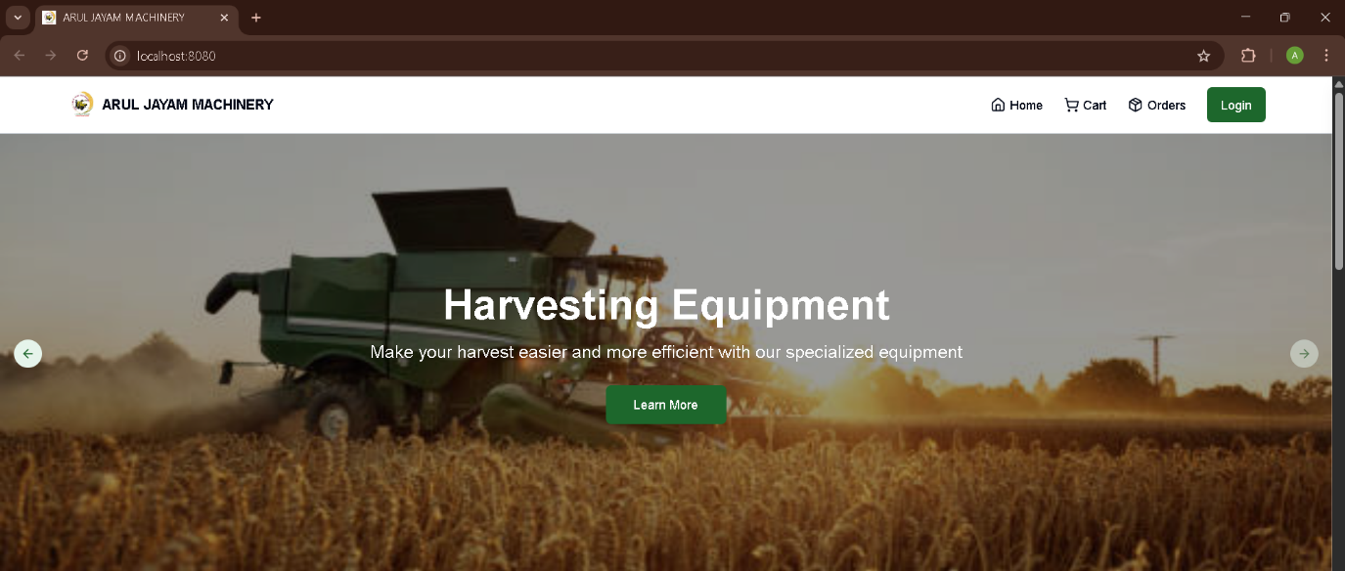

**FIGURE A2.1 HOME PAGE**



**FIGURE A2.2 PRODUCTS PAGE**



**FIGURE A2.3 CART PAGE**

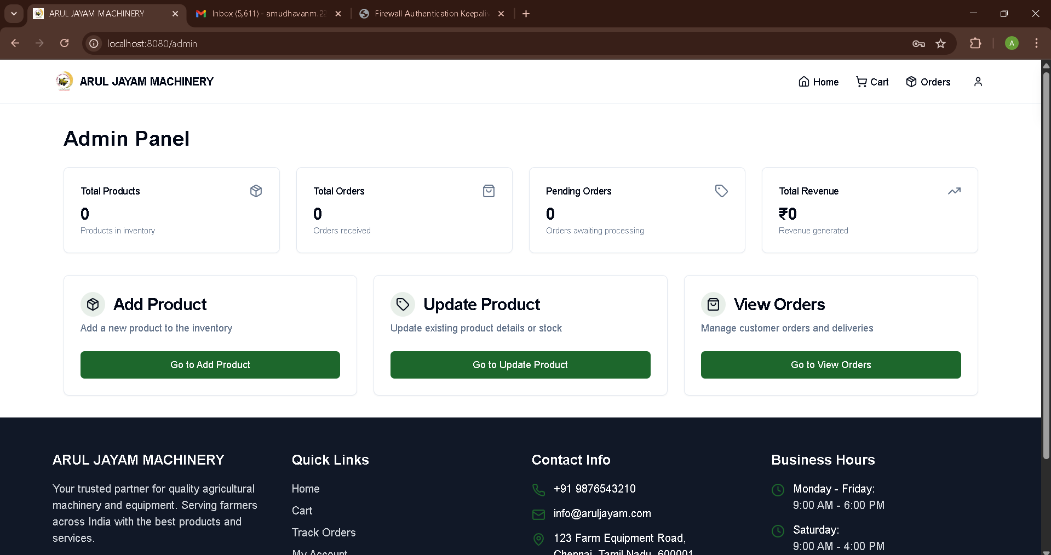

**FIGURE A2.4 ADMIN PANEL**

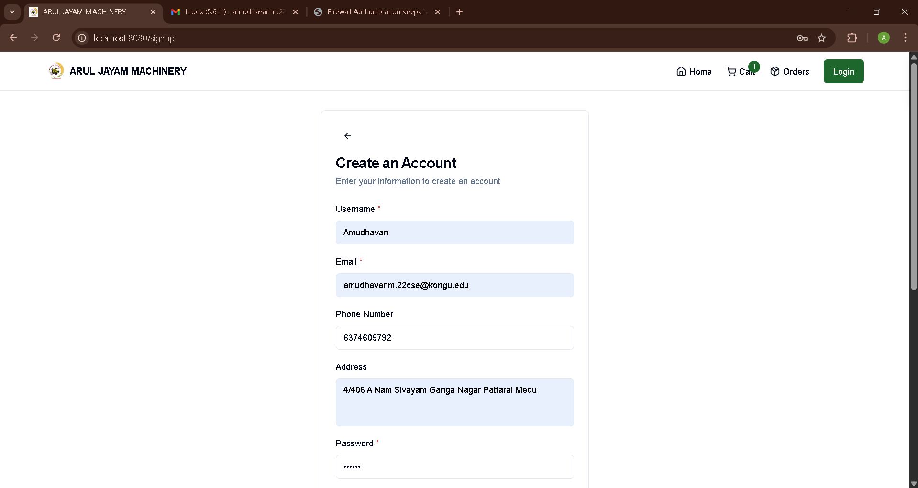

**FIGURE A2.5 USER SIGNUP PAGE**

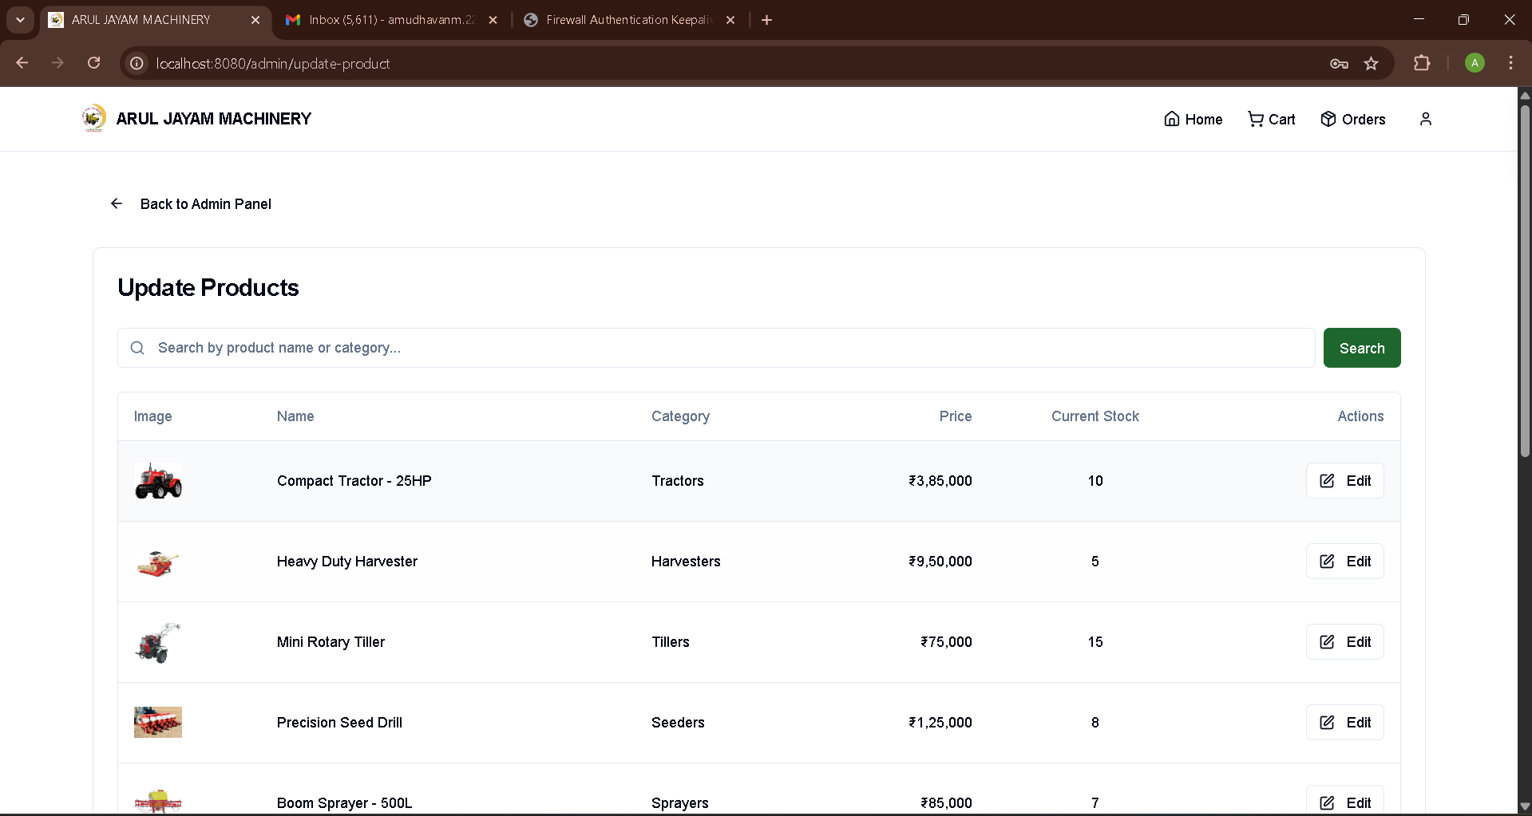

**FIGURE A2.6 PRODUCT MANAGEMENT PAGE**

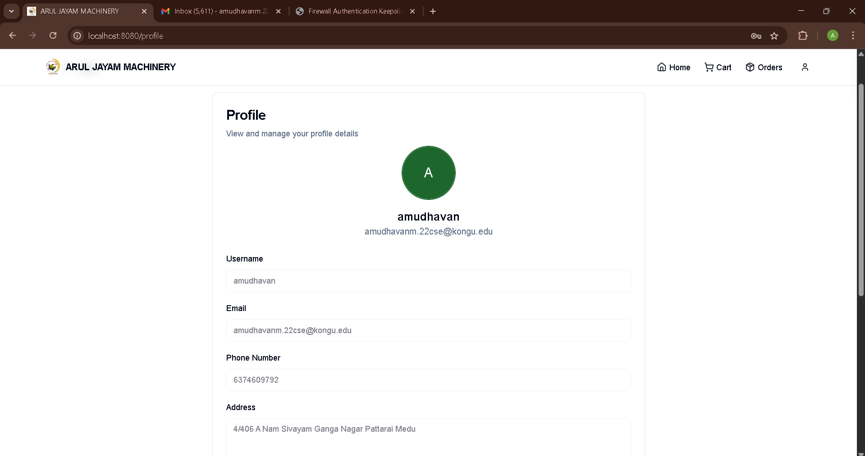

**FIGURE A2.7 USER PROFILE PAGE**

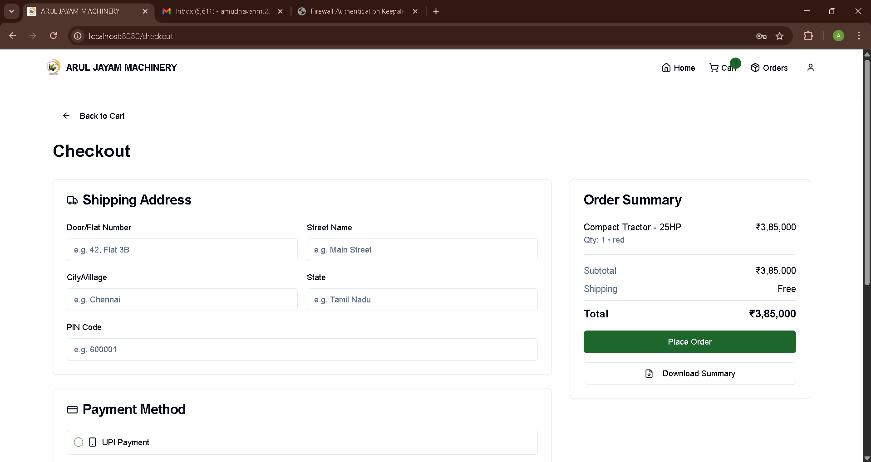

**FIGURE A2.8 CHECKOUT PAGE**

**REFERENCES**

|  |  |
| --- | --- |
| 1 | Mozilla Developer Network. "HTML & CSS Documentation." Available at: <https://developer.mozilla.org/> |
| 2 | React Documentation. "React – A JavaScript Library for Building User Interfaces." Meta Platforms, Inc. Available at: <https://reactjs.org/> |
| 3 | Express.js. "Fast, unopinionated, minimalist web framework for Node.js." Available at: <https://expressjs.com/> |
| 4 | MongoDB, Inc. "MongoDB Documentation." Available at: <https://www.mongodb.com/docs/> |
| 5 | Bootstrap. "Bootstrap · The most popular HTML, CSS, and JS library in the world." Available at: <https://getbootstrap.com/> |
| 6 | PayPal Developer. "Accept Payments with PayPal." Available at <https://developer.paypal.com/> |
| 7 | Netlify. "Deploy modern web projects in one click." Available at: <https://www.netlify.com/> |
| 8 | W3Schools. "Responsive Web Design." Available at: <https://www.w3schools.com/html/html_responsive.asp> |
| 9 | Cloudflare. "Performance & Security for Websites." Available at: <https://www.cloudflare.com/> |
| 10 | Kumar, A., & Sharma, R. (2022). "Design and Implementation of a Secure and Scalable E-Commerce Web Application." *International Journal of Web Applications*, vol. 15, no. 2, pp. 101–110. |